Duy Le – Code Documentation.

Team “Not Yet”

**What I Attributed to the Code**

My task for the coding portion of the project was to program the “Practice” and “Quiz” Section. Also, I have to figure out how to merge part together, and I only Code the Practice and Quiz, all the Questions were all figured out by Victor

**Specific Times During Programming Phase**

Thursday 10/31/2019 (9pm to 10pm): coding the layout for menu and the frame for the quiz (file xml)

Sunday 11/3/2019 (5pm to 6pm): creating database for quiz question

Sunday 11/3/2019 (6pm to 7.30pm): finishing the quiz activity class, question class and contract class

Sunday (11/10/2019): 1 hour: Fixing menu for quiz part in android studio, adding database connect helper to a class in the code

Thursday 11/14/2019: Fixing mistake with the xml file and the quiz activity class in 1hr

Friday 11/15/2019: create countdown timer and finish the quiz part in 3hr

Sunday 11/17/2019: Start coding practice part 2hr

Monday 11/25/2019: import all the quiz questions and practice questions from Victor’s file to the database of the project

Sunday 12-1-2019 10pm to Monday 12-2-2019 6pm: Merging all the part, figure out the API level

**Methods**

Firstly, I used databases to put all the questions in, and all of the questions will be stayed in the database inside of the android devices.

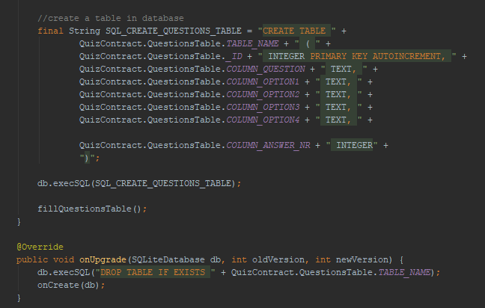

I created the table each time we import/install the file to the android devices, so I need one more function which is onUpgrade to detect if the table exist or not to be easier to update the app because we might put more data to the app in the future. The table contains Table Name, ID for each questions, and I will have 5 columns which is Questions, and 4 options for multiple choice.

Encapsulation:

Encapsulation is a really good attributes in Java, it helps me to handle the variables. I only need to create variables once for Questions, and each variable for each choice in multiple choice which supposed to be A, B, C, D for the users.

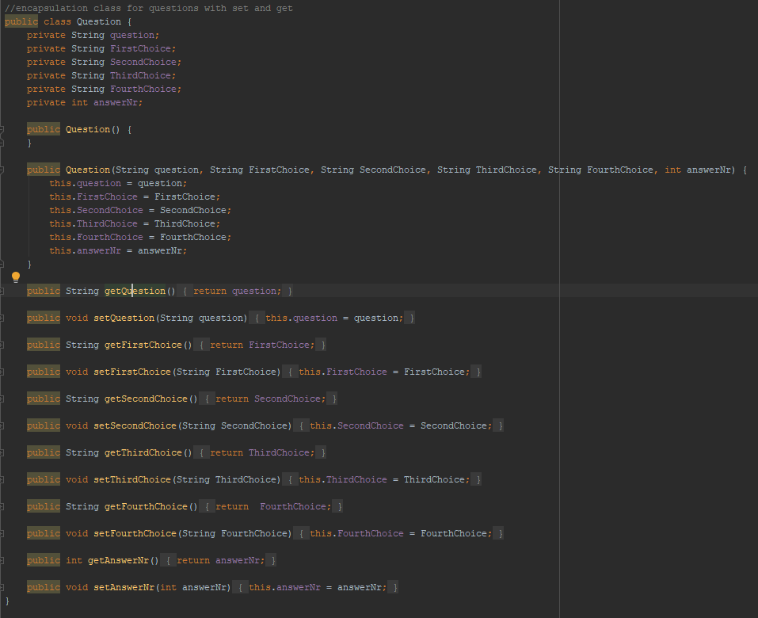

Like we see, I have created Set-Get function to import the data to the variable, and we can import multiple times for each question.

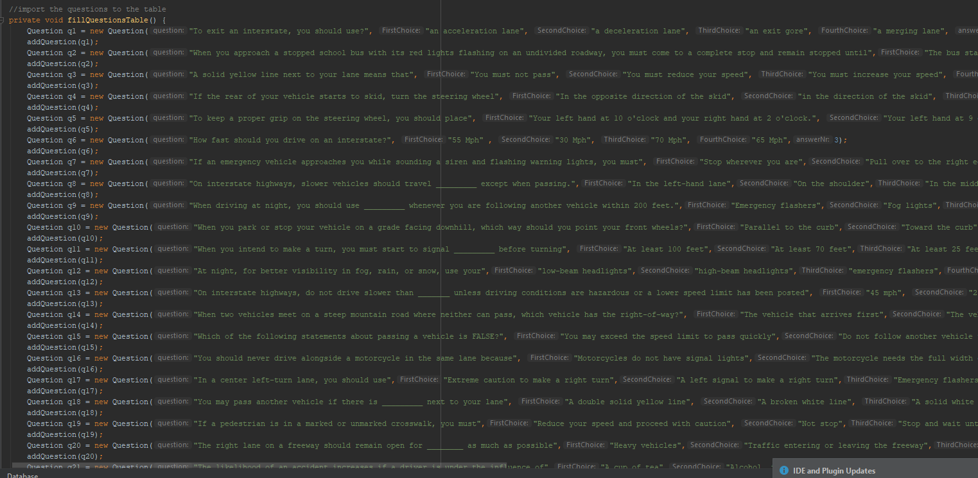

After Creating the Encapsulation class, I moved on importing the questions

To make these questions appear in the app, I used the syntax to connect database with android studio code 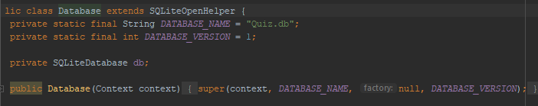

After having all of the questions and database, I work on how does the quiz work for user interface

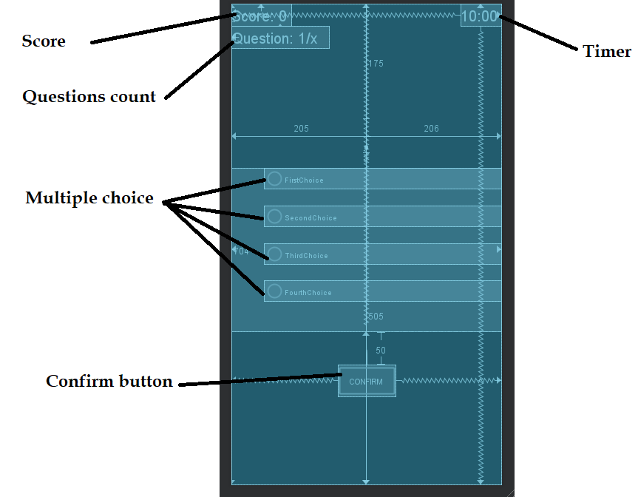

The Confirm button takes me the most time in this part, before making the confirmation button work, I need to collect the answer from the user. The user can only choose one option, and I put all of the choice in one radio group. The radio group helps me to change the choice if the user make the new decision, and the old choice will be unchecked.

After all of these thing, I wrote code to remember the information from the user

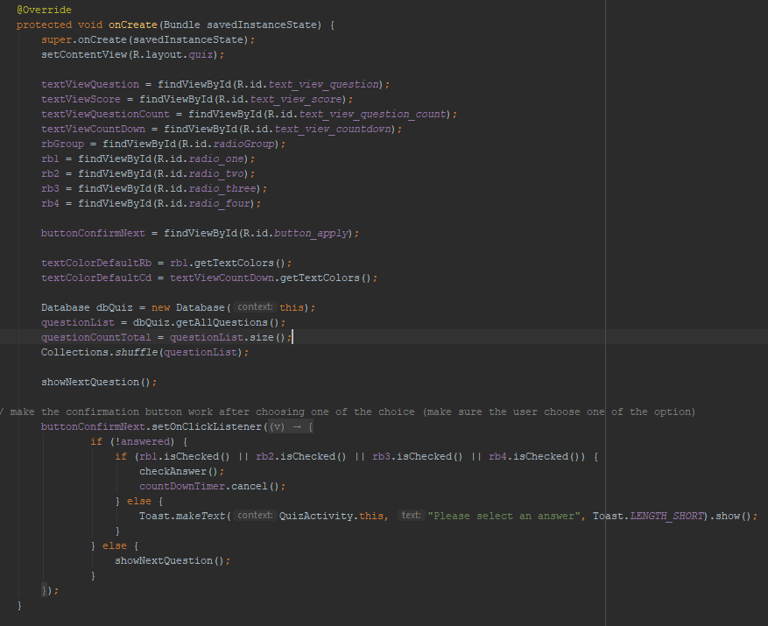

This code import the database when people start, and import the questions for the user. This main function for Quiz Activity helps us to check the answe correct for not, it also checks does the user choose one option or not and it will toast “Please select an answer” if the user choose nothing.

To make the confirmation button work, I used a function to show the next questions if the user didn’t answer all of the questions were given. It will become finish button if it is the last question for the quiz.

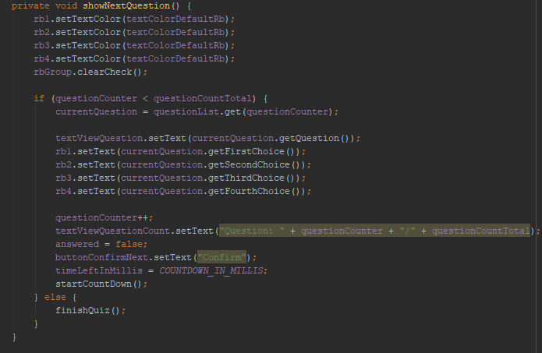 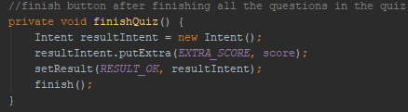

Using else – if function is really helpful for this part

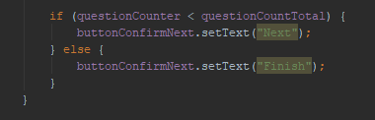

After answering each questions, people want to check does that correct or not, so I have a function to show the correct answer by highlighting using the different color. The correct one will be green, the in correct one will be red.

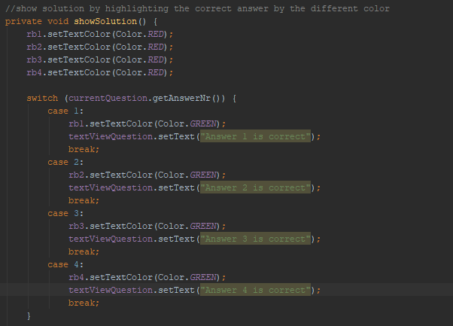

The next thing I worked on it is high score, I want people to challenge themselves, so they can attempt the quiz and then see how they get, the highest score will be kept in the device, so people will feel proud when we have the highest score. I was using some sources, and I understand how to figure out and make the timer work like real timer. It will be updated every second, each questions will be attempted in only 30 seconds to challenge the user.

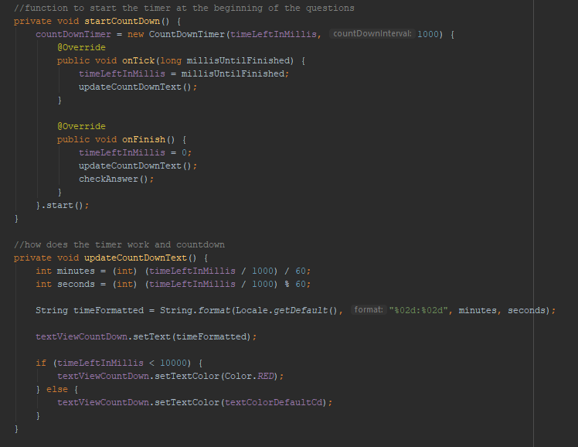

In main Quiz class, I moved the user to a different layout which contains High Score, start button, the title, and the background.

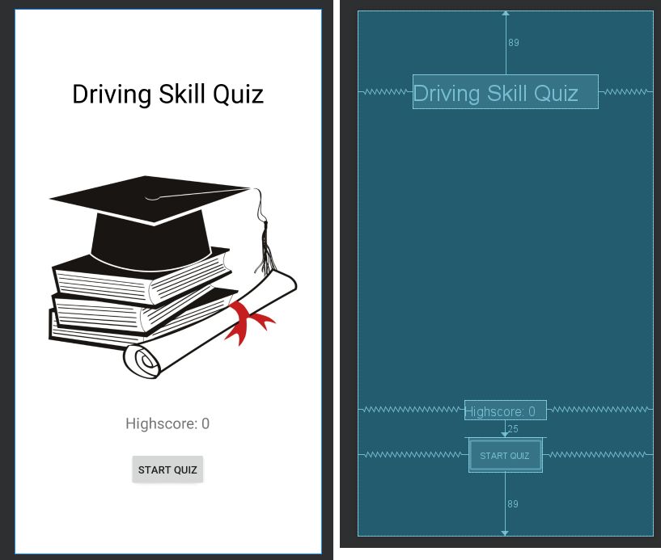

If the user click the button, I used an intent to move the user to a different layout to start challenging. In the main class, I need to show the highscore, and update it when people attempted a different highscore.

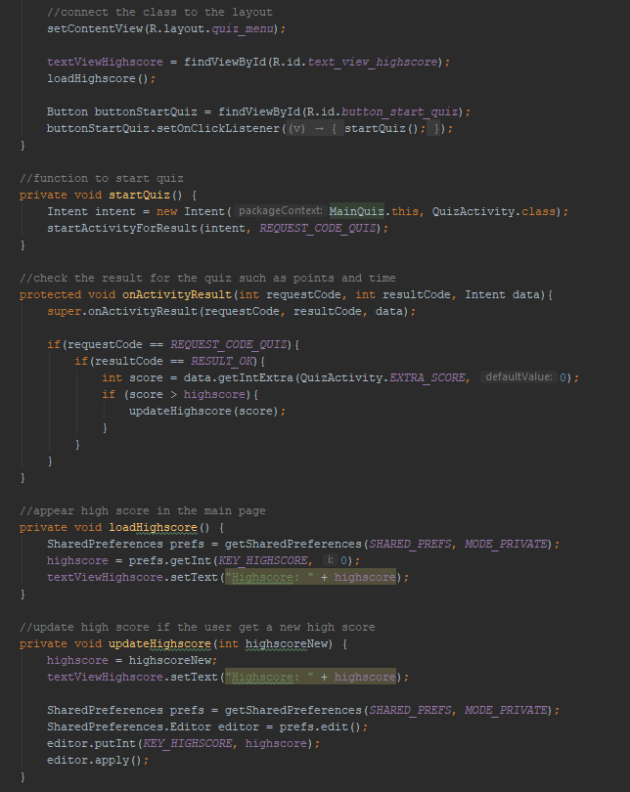

For the Practice Section, I still used the same code for Quiz, but I have changed the way to check the answer. The quiz will show us that we did it right or not after confirming the answer. The practice will toast to show the user that the answer is incorrect if the answer from the user is not correct. Also, after toasting, the checked radio button will be disappeared, and the user can choose the answer again until the answer is right.

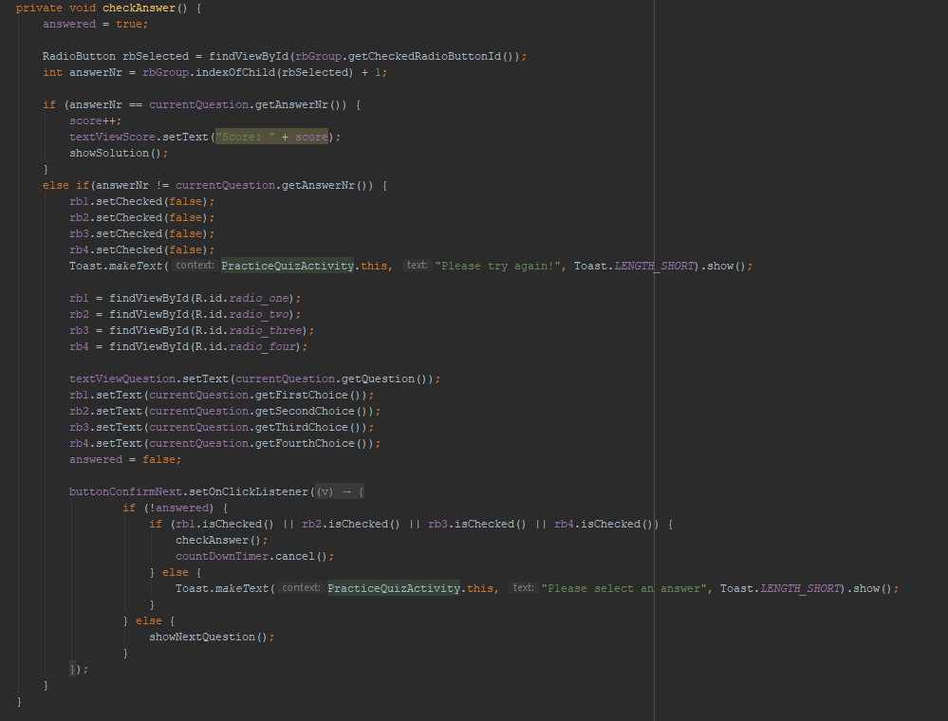

After checking on the user, this function need to collect new data from the user, so I repeated the code for checking answer to make sure this function work.

This is for practicing, so I used the exact same code for Quiz Section, but I cut down the highscore, but I still keep the timer for people who want to challenge themselves. If the timer reached 0, it won’t hurt the user, the user can still work on the same questions, and the timer will work again whenever the user click next for the next questions.

**\*MERGING\***

**For** merging all the part together, I have worked for a really hard time. I have no idea about the menu section, so I was failing on building the project to my computer. I wasn’t understand why didn’t I build it failed. However, I figured out the different way. I created a new project, import all of the class from all the part such as quiz, practice, learn, and the most important thing is main menu. The main menu needs to use a lot of things like recycle view, button navigation view, …

I need to import all of the external library from Gio’s project; also, I need to copy all of the layout, picture for the drawable part, values such as strings and colors, and the most important thing is the Gradle to build the project. After putting all of these, I tried to sync and build, and the project worked really well. I changed the view, put all of quiz, practice, and learn part in all of the default buttons were given in the main menu by using intent, and one function to call the class belong to the layout. I need to put more stuffs in main activity. The main activity need to import all of the class in to make the intent work. After doing all of these things, I was successfully have the completed app for all of works from the whole team. Clap clap! 

Sources Used

* Connecting SQL with Android Studio: Codinginflow.com
* Making Quiz interface: Some of the Youtube Video

Bugs:

* Crashing when I choose an option from multiple choice: I have 2 radio listener, one comes from the class, and another one comes from the layout, the one in layout collect the ID, then send it to the class and the one in class collect all of the RB button and see which one is chosen. The thing I do to fix this mistake is deleting the one in layout, and then I only have the one in class. The conflict has gone, and the quiz works smoothly.
* Troubling when connecting all the part together is the different API level between Gio’s part and Duy’s part. I used API level 15, but Gio used another one with API level 26, which supports the Recycler and Button Navigation View.